- To create a Quaver online student account, begin by visiting www.quavermusic.com and click "Log In" on the top right of the screen. You will then be directed to the screen below…click “Need a Quaver Account”
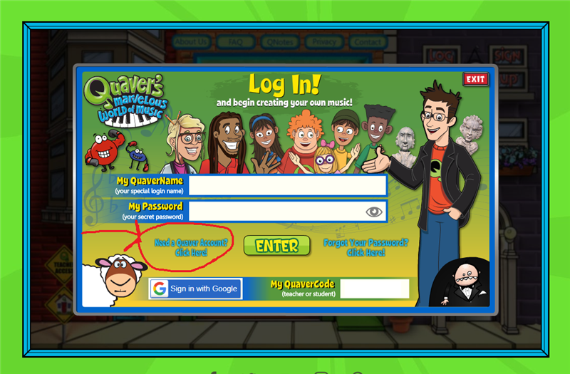
- Use a username and password that is easy to remember. (Maybe one you use for other educational websites)
- Insert the class QuaverCode that matches your grade level.
Kindergarten: 8B82W
1st Grade: EYHL8
2nd Grade: VAVE8
3rd Grade: DQSEX
4th Grade: NG5JY
5th Grade: FH5CF
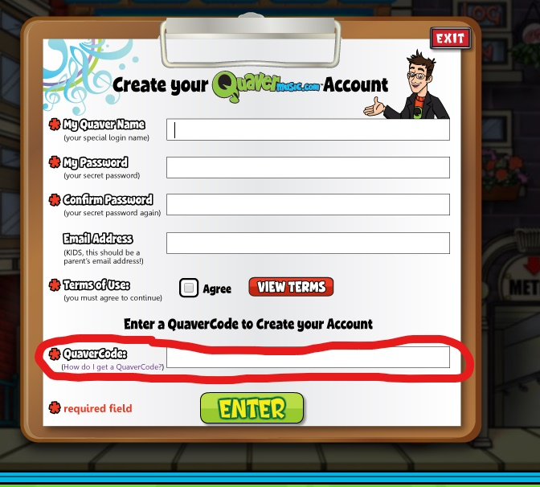
- After you have set up your account you just need to log in each time.

*You do not need an email to set up an account.

